Day 1 - 14th May 2025
SDLC:
Task 1:
What is SDLC ?
SDLC stands for Software Development Life Cycle. It’s a step-by-step process that helps teams create software in an organized way. It is like a recipe for building software. SDLC helps make sure the software is built properly, works well, and keeps improving over time. It includes main steps:
- Planning – First, we figure out what the software is supposed to do and why we need it.
- Analysis – Then, we look at the details of what features the software should have.
- Design – Next, we plan how the software will look and how it will work behind the scenes.
- Development – This is where the actual coding happens to build the software.
- Testing – After coding, we test everything to make sure it works properly and there are no bugs.
- Deployment – Once everything is ready, we release the software so users can start using it.
- Maintenance – Even after release, we keep checking and fixing any issues or adding updates.
Task:2

What is SDLC in simple words ?
Simple explanation of SDLC (Software Development Life Cycle):
- Plan – Understand what the software should do and why it’s needed.
- Design – Create a blueprint for how the software will look and work.
- Build – Write the code to develop the software.
- Test – Check the software for any mistakes or bugs.
- Launch & Maintain – Release it to users and keep improving or fixing it as needed.

Task 3:
What are the different stages in SDLC?
Different the stages in the SDLC:
- Planning
- Requirement Analysis
- Design
- Development
- Testing
- Deployment
- Maintenance
Task no 4:
SDLC Models:
List them , describe - 4 lines min and with a image
List of SDLC Models:
- Waterfall Model
- V-Model
- Incremental Model
- Iterative Model
- Spiral Model
- Agile Model
- Big Bang Model
1. Waterfall Model
Waterfall model is like a step-by-step process. First, we gather all the requirements, then design, then build, then test, and finally deliver the product.
2. V-Model
The V-Model is kind of like the Waterfall model but with more focus on testing. For every step we do in development, there’s a matching testing step.
3. Incremental Model
With the Incremental model, we build the project bit by bit. We don’t wait to finish the whole thing, we create small parts that work and add more features later.
4. Iterative Model
In the Iterative model, we build something, test it, and improve it again and again. It’s like making many versions of the same product and making each one better.
5. Spiral Model
The Spiral model is for big and risky projects. It works in rounds or "spirals." In each round, we plan, check for risks, build, and get feedback. Then we repeat the process.
6. Agile Model
Agile is flexible and fast. We work in small teams and break the work into short tasks called sprints. After each sprint, we deliver a working part of the product and get feedback.
7. Big Bang Model
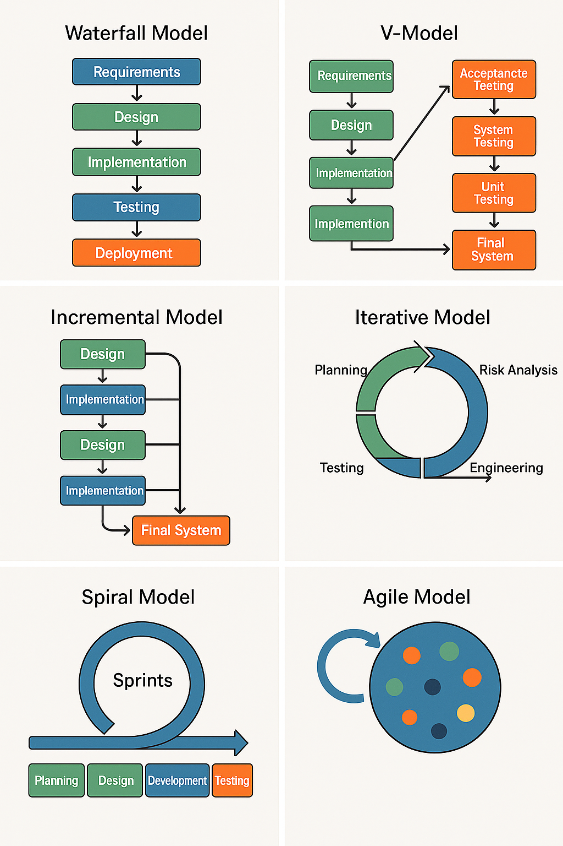
The Big Bang model is super simple and doesn’t have much planning. We just start building with whatever we have and hope it all comes together. It can work for small or experimental projects, but it’s risky because there’s no real structure or planning.

Networking Concepts
Task 5:
What are the different Network types?
1. Personal Area Network (PAN): Connects devices around a single person, such as a smartphone, laptop, and Bluetooth headset.

2. Local Area Network (LAN): Connects devices within a limited geographical area, such as a home, office, or school.

3. Wireless Local Area Network (WLAN): Similar to a LAN but uses wireless technology (like Wi-Fi) instead of cables. Such as a home Wi-Fi network.

4. Metropolitan Area Network (MAN): Connects devices across a city or metropolitan area.
Such as a network connecting businesses and residential buildings within a city.

5. Wide Area Network (WAN): Connects devices across a large geographical area, such as a country or the world such as the Internet is a WAN.
6. Virtual Private Network (VPN): Creates a secure, encrypted connection over a public network, often the internet, allowing users to access a private network from a remote location. Such as a VPN connecting a remote worker to their company's network.

Task 6:
What are the types of servers ?
1. Web Server
It delivers websites to your browser. When you open a website, a web server sends the pages to us.

2. Mail Server
Handles sending and receiving emails. It stores your emails and makes sure they go to the right place. Example: Microsoft Exchange, Gmail servers.

3. File Server
Stores and manages files so users on a network can access, share, or edit them.such as a shared folder for an office.

4. Application Server
Runs specific apps for users, often in the background. It connects web servers to databases and processes things like logins, forms, or purchases.

5. Database Server
Stores and organizes data. Other servers or applications connect to it to save or read data. Like MySQL
6. Proxy Server
Acts as a middleman between our device and the internet. It helps with security, filtering, and sometimes speeds up browsing.

7. Authentication Server
Manages login info and makes sure only the right people get access to the system or network.

8. Game Server
Used in online multiplayer games. It keeps the game world running and lets players connect and interact in real-time.

9. Print Server
Controls printers on a network. It manages printing jobs sent from multiple devices to one or more printers.

Task 7:
This is Verbal task

What do you know about DNS? Domain Name
A domain name is like a name of a website for as example facebook.com, youtube.com.we type in the browser to visit a site. Each website has a unique domain name. DNS helps find the real address of that website, which is a number called an IP address. So we don't have to remember numbers
Task 8:
What is TCP and UDP? What is the difference?

TCP stands for Transmission Control Protocol.
It makes sure that all data sent from one computer to another arrives correctly and in the right order. It’s like sending a letter by post and getting a delivery receipt.
UDP stands for User Datagram Protocol.
It sends data faster but doesn’t check if it gets delivered properly. It’s like sending a message quickly without waiting for a reply.
Difference between TCP and UDP:
TCP makes sure all data is delivered correctly and in the right order. Where as UDP sends data quickly but doesn’t check if it arrives properly.
TCP is slower because it checks everything. But UDP is faster because it doesn’t do any checking.
TCP is used for things like websites, emails, and file downloads where accuracy is important. Whereas UDP is used for things like video calls, online games, and live streaming where speed matters more.
Task 9:
What do you know about mac addresses ? What is the difference between Mac address and IP address.
A MAC address (Media Access Control address) is a unique ID given to every device when they are manufactured that connects to a network, for example mobile, laptop, routers, printers. It is like a permanent name tag for our devices
Difference between MAC Address and IP Address:
A MAC address is a hardware address, it’s fixed and set by the device manufacturer. But an IP address is a software address, it can change depending on where and how we're connected.
A MAC address stays the same. But where as IP addresses can change like when we connect to different Wi-Fi networks.
Task 10:
This is both Written and Oral.. You guys need to answer this question and share your screen and explain to us your understanding..
What is the OSI model ?
The OSI Model stands for Open Systems Interconnection Model.
It’s a way to understand how data moves through a computer network.
The model has 7 layers, and each layer has a specific job.
The 7 Layers:
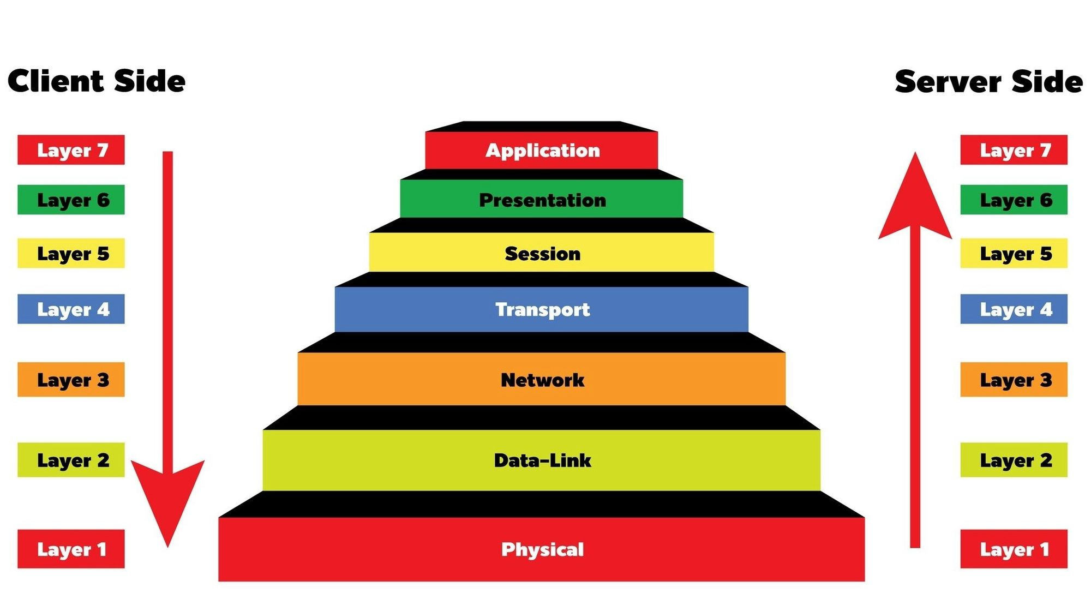

- Application Layer – This is where users interact with the network, like using a web browser or email. For example, in a web browser application, the Application layer protocol HTTP packages the data needed to send and receive web page content. This layer provides data to (and obtains data from) the Presentation layer.
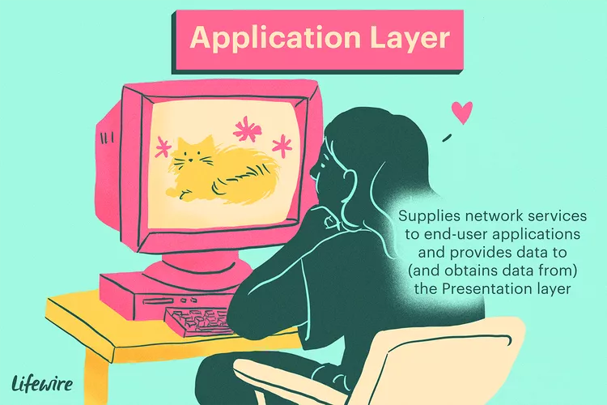
- Presentation Layer – It formats the data so both sides understand it (like converting text or images). It handles syntax processing such as format conversions and encryption/decryption needed to support the Application layer above it.
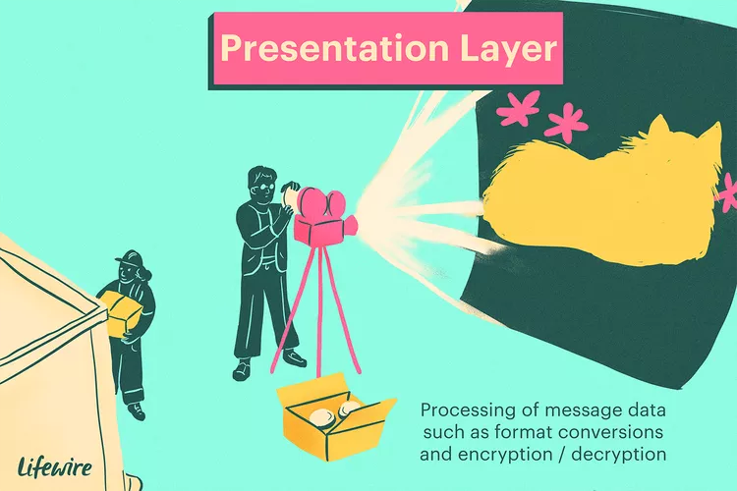

- Session Layer – it manages the connection between two devices (starting, using, and ending a session). 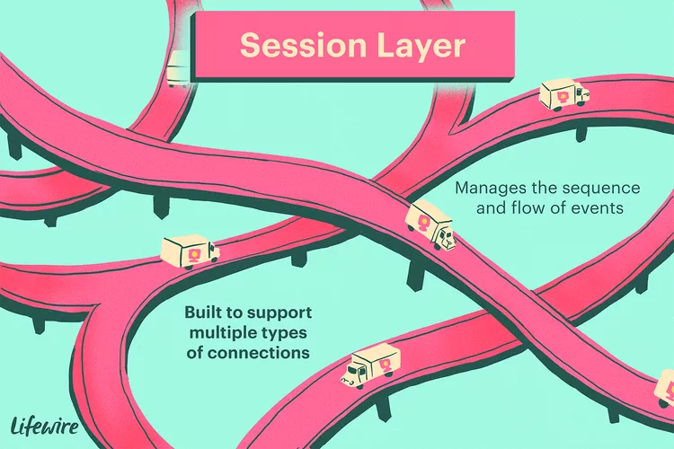
- Transport Layer – it delivers data across network connections. Breaks data into pieces and makes sure it gets delivered correctly (uses TCP/UDP). It may support a range of optional capabilities like including error recovery, flow control, and support for re-transmission.
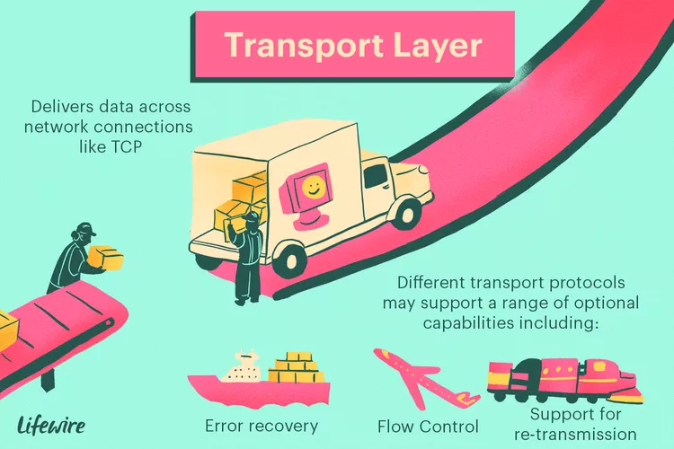
- Network Layer – To support routing, the Network layer maintains logical addresses such as IP addresses for devices on the network. It also manages the mapping between these logical addresses(IP addresses) and physical addresses(MAC).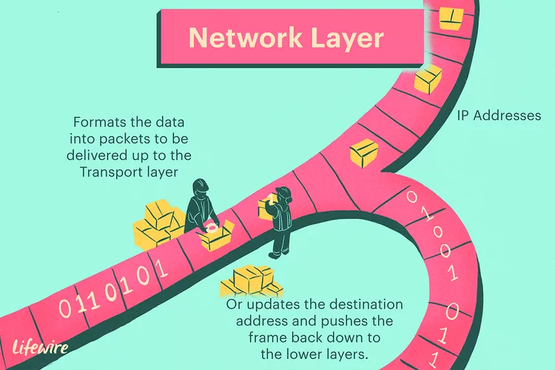
- Data Link Layer – When obtaining data from the Physical layer, the Data Link layer checks for physical transmission errors and packages bits into data frames. The Data Link layer also manages physical addressing schemes such as MAC addresses for Ethernet networks, controlling access of network devices to the physical medium.
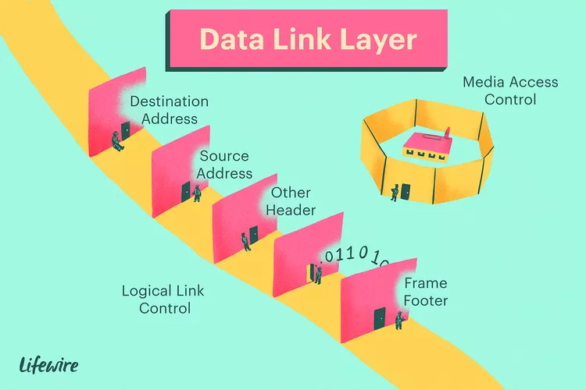
- Physical Layer – it is responsible for the transmission of digital data bits from the Physical layer of the sending (source) device over network communications media to the Physical layer of the receiving (destination) device.
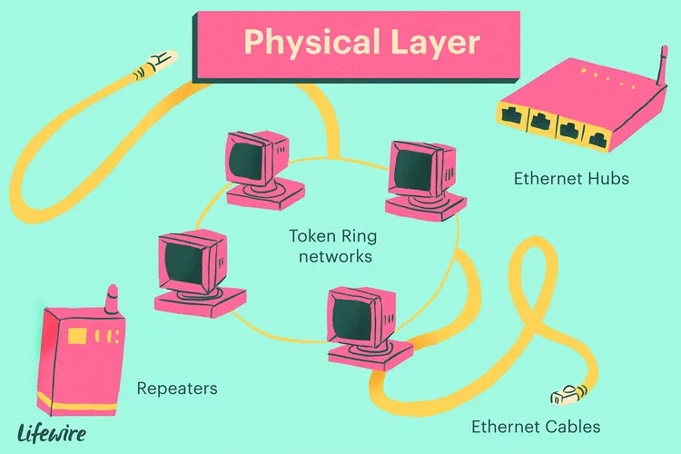
Task 11:
What is an IPv4 address? What are the different classes of IPv4?
IPv4 address is like that address for computers on the internet. It's a special number that identifies each device. it's written in four parts, with dots in between, like 192.168.1.1. Each part is a number from 0 to 255.
IPv4 addresses are divided into 5 classes (A, B, C, D, and E)
Class A: Used for Very large networks (like big companies or ISPs)The addresses started with a number from 1 to 126. For example,10.0.0.1

Class B: Used for Medium-sized networks (like universities or large businesses) The addresses started with a number from 128 to 191.For example: 172.16.0.1
Class C: Used for Small networks (like homes or small offices)The addresses started with a number from 192 to 223. You might see something like "192.168.1." with different last numbers for your phone, laptop, etc.
Class D: Used for Multicasting (sending data to many devices at once, like video streaming). The addresses started from 224 to 239.
Class E: Used for Research and future use (not for general public) like areas that aren't open to the public yet. They started from 240 to 255.
Task 12:
What are the advantages of using VPN?
- Hides IP addresses – Keeps our real location private.
- Secures our data – Encrypts our internet traffic so hackers can’t steal it.
- Protects on public Wi-Fi – Keeps you safe when using open networks like in cafes or airports.
- Access blocked websites – Helps you open websites that are restricted in our country or region.
- Avoids tracking – Stops websites and apps from following what you do online.
- Safe remote access – Employees can securely connect to their office network from anywhere.
Task 13:
Types of VPN
Give 1 liner for each: Access VPN,Site to site vpn,Intranet VPN,Extranet VPN
Access VPN:Allows individual users to securely connect to a private network from a remote location.
Site-to-Site VPN:Connects two or more office networks in different locations over the internet securely.
Intranet VPN: Used within a company to securely connect different branches to the main office network.
Extranet VPN: Allows business partners or vendors to securely access certain parts of a company’s private network.
Task 14:
Node and link
A node is any device connected to a network.
A link is the connection between two nodes in a network.
Example: Imagine we have two computers and a cable.
Each computer is a node (a device on the network).
The cable connecting them is the link (the pathway for data).
Task 15:
Topology means: how the devices in a network are connected together.
Task 16:

Different types of network topology:

Bus Topology: In this type, all the computers are connected to a single cable. If the main cable breaks, the whole network stops working.

Star Topology: All devices are connected to one central device like a switch or hub. If one computer has a problem, the others are still fine. but if the central device fails, the network goes down.

Ring Topology: Here, each device is connected to two others, forming a circle.

Data goes around the ring, and if one link breaks, the whole network might stop.

Mesh Topology: Every device is connected to every other device directly. This makes it very strong and reliable, but it’s also expensive and hard to set up.

Tree Topology:This looks like a tree, it’s a mix of star and bus topologies. It’s good for large networks, and easy to expand by adding branches.

Hybrid Topology: It combines two or more different topologies like star and ring. It’s flexible and used in big organizations with complex networking needs.
Task 17:
What is extended bus topology ? its a Tree Topology.
Extended Bus Topology (Tree Topology)
Extended Bus Topology is a variation of Bus Topology that follows a hierarchical structure, making it similar to Tree Topology.
Key Features:
🔹 Hierarchical Design – A central backbone connects multiple branches, resembling a tree.
🔹 Scalability – Allows easy expansion by adding more nodes.
🔹 Combination of Bus & Star – Uses a main bus with multiple star-connected segments.
🔹 Efficient Data Flow – Ensures structured communication between nodes.
🔹 Common in Large Networks – Used in corporate and educational institutions.
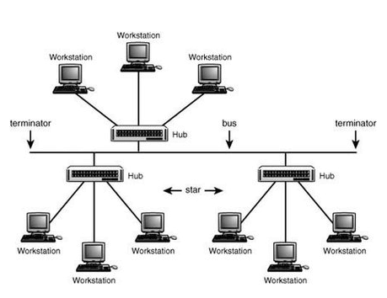
Task 18:
What is the use of a router and how is it different from a gateway?
A router connects multiple networks and directs network traffic between them. Most commonly, it connects a local network (LAN) to the internet (a WAN). For example, a Home Wi-Fi router connects your laptop, phone, and smart TV to the internet and handles communication between them.
A Gateway Connects different kinds of networks that might speak different "languages" (protocols). It translates data between them.
Task 19:
Explain SMTP Protocol with a diagram.
SMTP (Simple Mail Transfer Protocol) is an email communication protocol that is used by mail servers to send emails from one account to another via the internet.
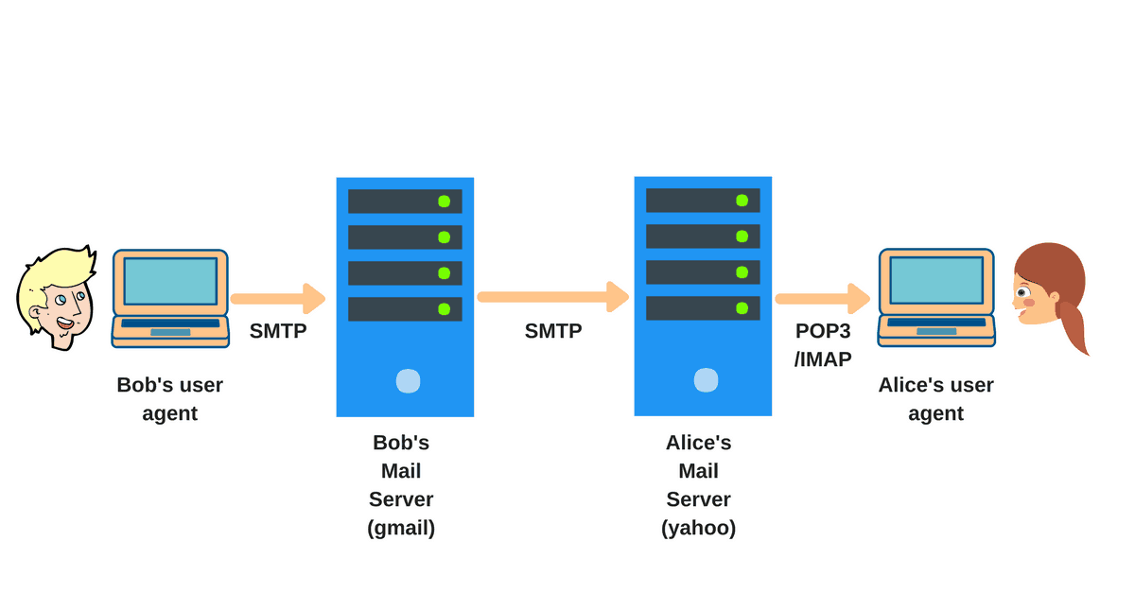
There are two primary components of the SMTP client and SMTP server:
User-agent (UA) is responsible for preparing, creating, and putting the message in the form of an envelope for transmission.
Mail transfer agent (MTA) then transfers this message to the recipient across the internet.
Task 20:
Difference between osi & tcp/ip
The OSI (Open Systems Interconnection) and TCP/IP (Transmission Control Protocol/Internet Protocol) models are both conceptual frameworks that describe how network communication happens. However, they differ in their structure, focus, and real-world application.
OSI Model:
- Layers: Has seven distinct layers, each with a specific function:
  - Physical: Deals with the physical transmission of data (cables, signals).
  - Data Link: Handles data transfer between two directly connected devices (MAC addresses).
  - Network: Responsible for routing data across networks (IP addresses).
  - Transport: Ensures reliable and ordered delivery of data (TCP, UDP).
  - Session: Manages connections and sessions between applications.
  - Presentation: Handles data formatting, encryption, and compression.
  - Application: Provides network services to end-user applications (HTTP, SMTP, DNS).
- Focus: A theoretical, general model intended to describe all forms of network communication. It's protocol-independent.
- Real-world Applicability: Not directly implemented; serves as a reference model for understanding network processes and troubleshooting.
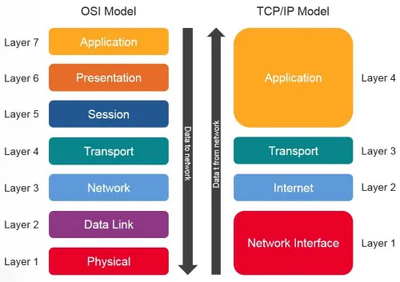

TCP/IP Model:
- Layers: Has a simpler, four-layer structure:
  - Network Access (or Link): Combines the OSI Physical and Data Link layers; handles physical connections and data transfer within a local network.
  - Internet (or Network): Similar to the OSI Network layer; responsible for IP addressing and routing.
  - Transport: Similar to the OSI Transport layer; provides connection-oriented (TCP) and connectionless (UDP) services.
  - Application: Combines the OSI Session, Presentation, and Application layers; provides protocols for end-user applications.
- Focus: A practical model based on the specific protocols used in the internet. It's protocol-dependent.
- Real-world Applicability: The foundation of the internet and most modern networks. The protocols in this model (TCP, IP, HTTP, etc.) are directly implemented.
Task 21:
What is HTTP and HTTPs
HTTP (Hypertext Transfer Protocol)
HTTP is the foundation of data communication on the web. It allows browsers and servers to exchange information, enabling you to access websites. However, HTTP data is not encrypted, meaning it can be intercepted by attackers.
HTTPS (Hypertext Transfer Protocol Secure)
HTTPS is the secure version of HTTP. It uses SSL/TLS encryption, which ensures that the data exchanged between your browser and the server is protected from unauthorized access. This is why websites handling sensitive information—like banking or login pages—use HTTPS.
Task 22:
What is Low Level Design and High level Design.. Explain
In the Software Development Life Cycle (SDLC), design is divided into two key phases: High-Level Design (HLD) and Low-Level Design (LLD). Both are essential for building a well-structured software system.
High-Level Design (HLD)
This phase focuses on the big picture of the system. It defines:
- System architecture and structure
- Main components and their interactions
- Data flow between modules
- Technology stack and frameworks
- Security measures and performance considerations
Essentially, HLD provides a blueprint that outlines how the system will function without diving into implementation details.
Low-Level Design (LLD)
This phase breaks down HLD into detailed components for implementation. It includes:
- Class diagrams and object-oriented designs
- Algorithms and logic for individual modules
- Database schema and data structures
- API specifications and function definitions
- Error handling and optimization techniques
LLD is like a detailed instruction manual for developers, ensuring that each part of the system is correctly implemented.
Task 23:
What is SRS (Software Requirement Specification). explain in 3 to 4 lines with a diagram.
Software Requirements Specification (SRS) is a document that outlines the functional and non-functional requirements of a software system. It serves as a blueprint for developers, testers, and stakeholders, ensuring clarity in expectations. SRS includes system objectives, constraints, assumptions, and dependencies, helping teams build software efficiently
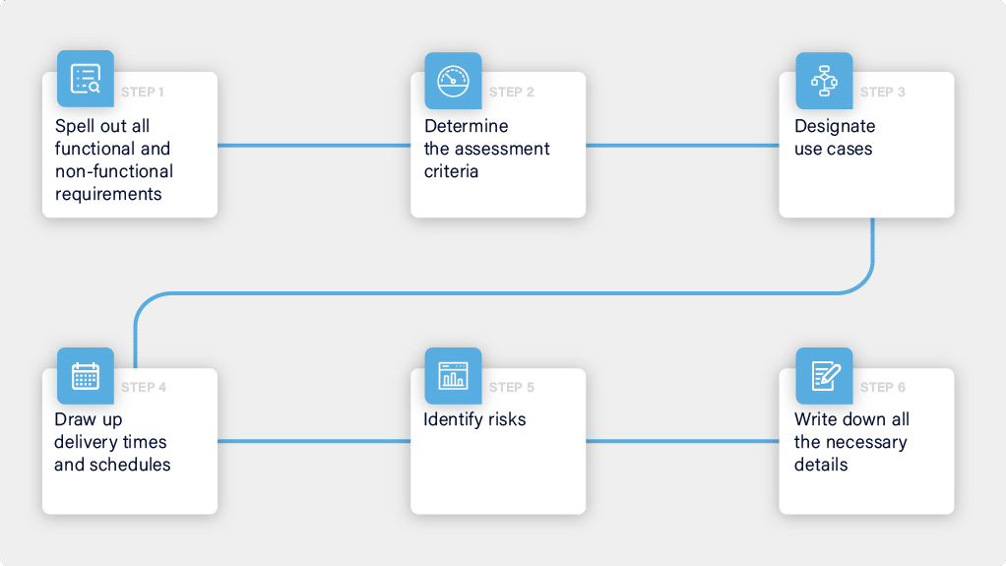
SDLC MCQ
1.
A feasibility study using the SDLC model is conducted to
determine whether or not the project is technically possible
determine whether the proposal is financially viable
Both a and b
None of the above
2.
A well-documented life cycle model aids in the detection of what during the development phase?
Inconsistencies
Redundancies
Omission
All of the above
3.
How many lines of code does the Build & Fix Model suit for programming exercises?
100-200
300-400
600-700
Above 800+
4.
In which life cycle does regression testing play a significant role?
Waterfall model
V model
Iterative model
All of the above
5.
What determines if the project should go forward?
feasibility assessment
opportunity identification
system evaluation
program specification
6.
What is the most significant disadvantage of employing the RAD Model?
Developers/designers that are highly specialized and skilled are required.
Component reusability is improved.
Encourages client/customer input.
Increases component reusability.
7.
Which of the following developmental models is incremental?
Prototyping, V model, Agile
Prototyping, RAD, Agile, RUP
Prototyping, V model, RAD, Agile, RUP
All of the above
8.
Which of the following is an Agile development characteristic?
Shared code ownership
Test-Driven Development
Implement the simplest solution to meet today's problem
Continual feedback from customer
All of the above
9.
Which of the following steps in the SDLC framework are valid?
Requirement Gathering
Software Design
System Analysis
All of the above
10.
Who is in charge of system development, staffing, budgeting, and reporting, as well as ensuring that deadlines are met?
Project managers
Network engineers
Graphic designers
Systems analysts

